Coding Test Answers:

13. Visit any application (E-Commerce or Banking) and document the steps with screen shot.

Amazon E-commerce website:

Step 1: Log In/Sign Up page

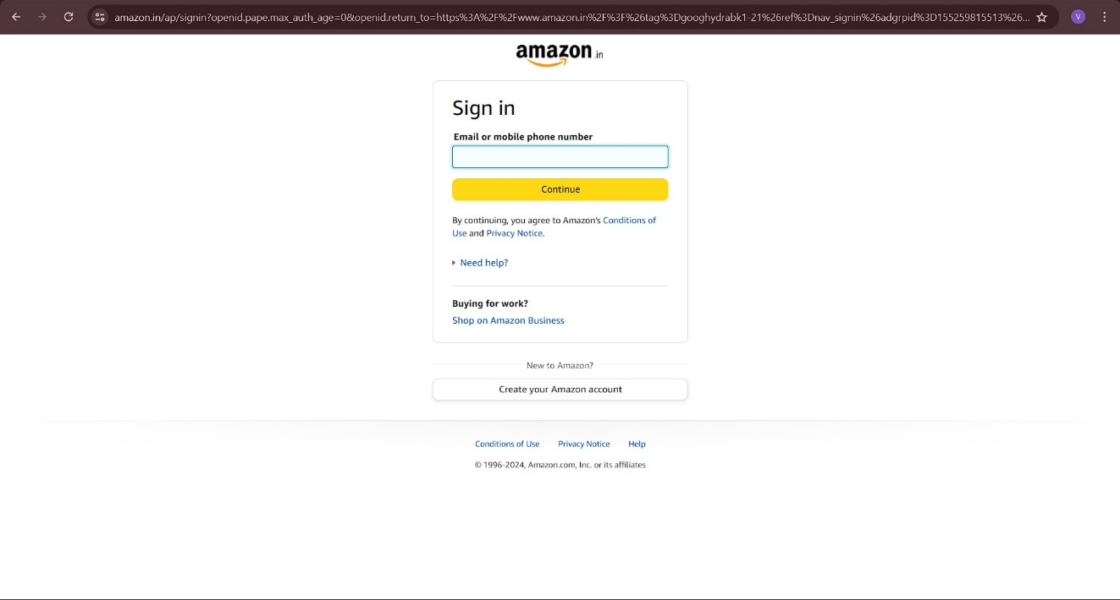

Step 2: Home page

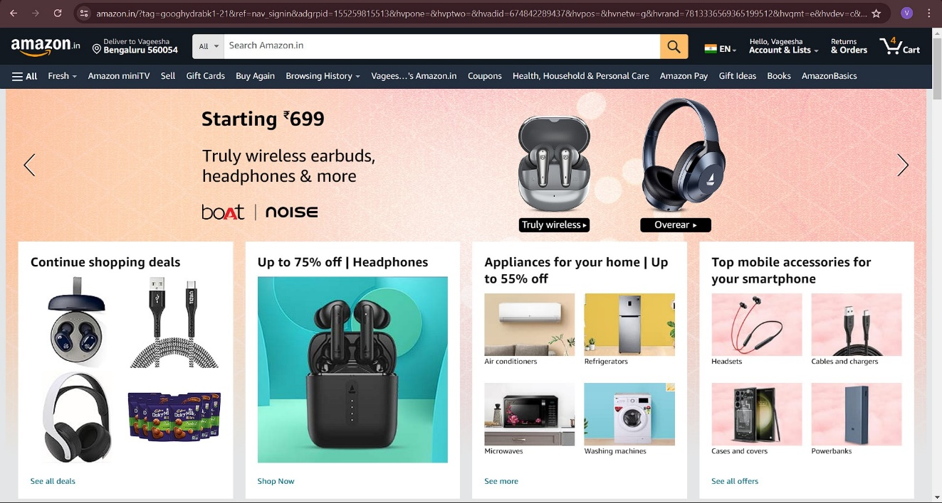

Step 3: Finding the product

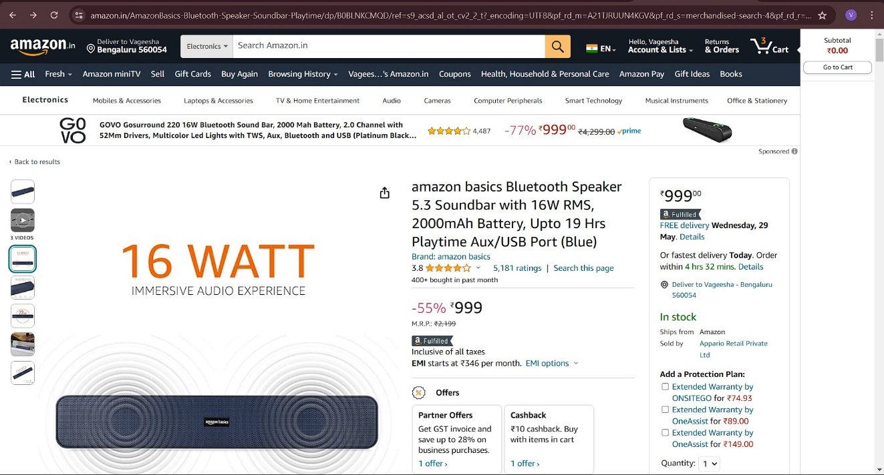

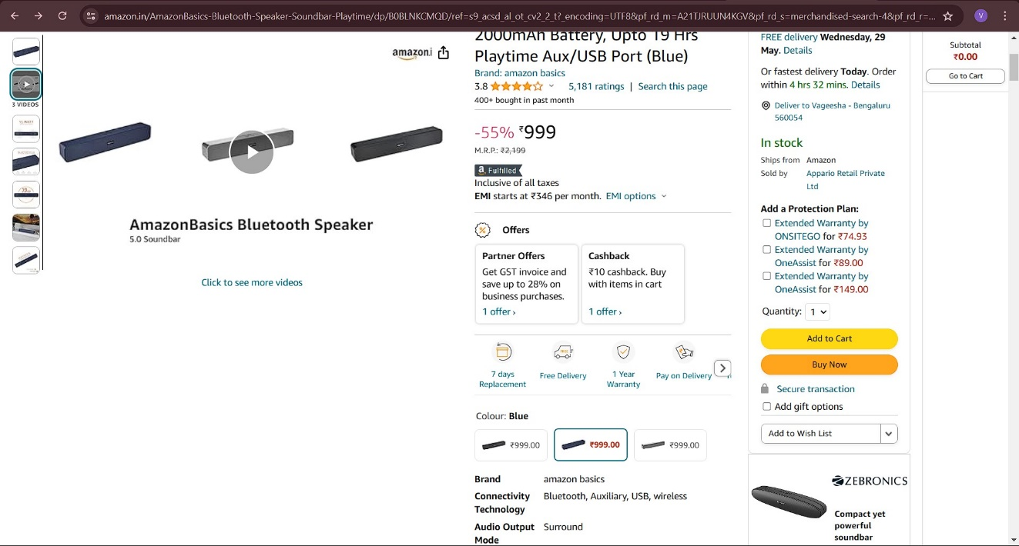

Step 4: After clicking on “Buy Now”

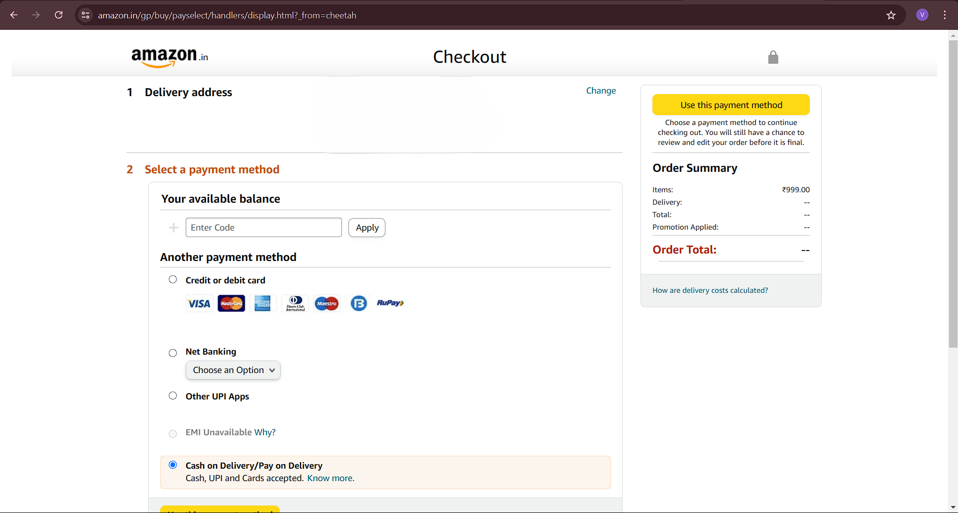

Step 5: Choosing the payment Method

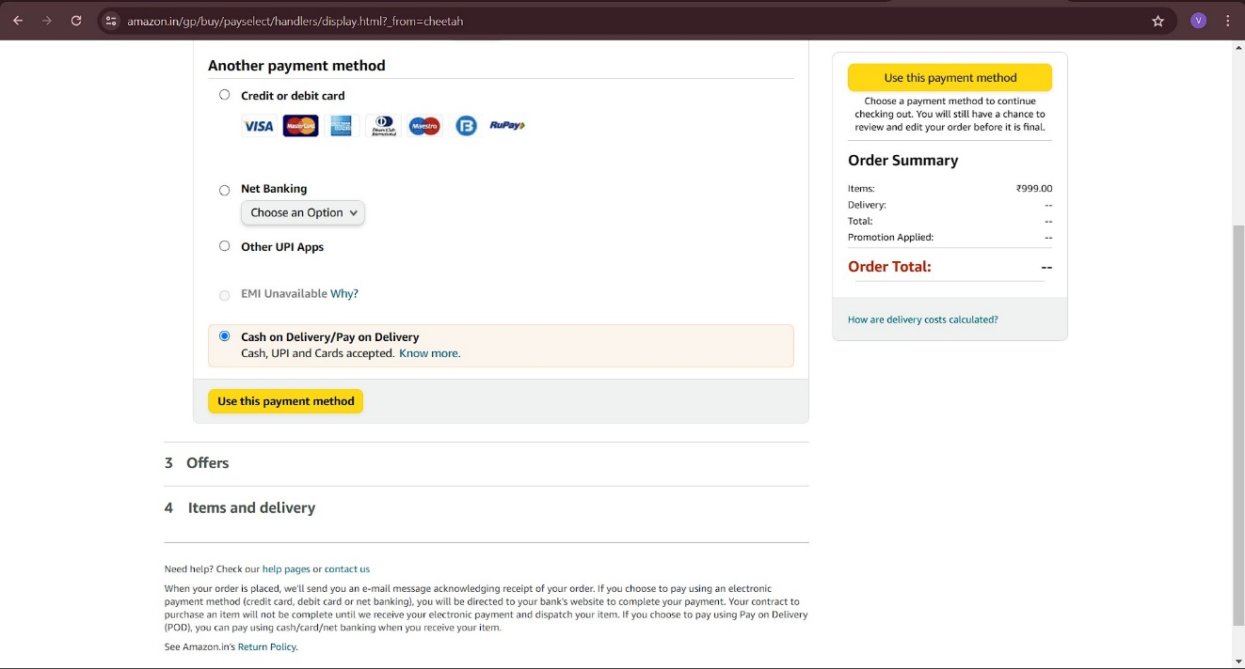

Step 6: Placing the order

